
AMERICAN INTERNATIONAL UNIVERSITY-BANGLADESH

Faculty of Engineering

Lab Report

Experiment # 06
Experiment Title: Communication between two Arduino Boards using SPI.

Date of Performance: | 15 April 2026 | Date of Submission: | 21 April 2026
Course Title: | Microprocessor and Embedded Systems Lab
Course Code: | EEE4103 | Section: | J
Semester: | Spring 25-26 | Degree Program: | BSc in CSE
Course Teacher: | Md. Rukonuzzaman
Declaration and Statement of Authorship:
- I/we hold a copy of this Assignment/Case Study, which can be produced if the original is lost/damaged.
- This Assignment/Case Study is my/our original work; no part has been copied from any other student’s work or any other source except where due acknowledgment ismade.
- No part of this Assignment/Case Study has been written for me/us by any other person except where such collaboration has been authorized. by the concerned teacher and is acknowledged in the assignment.
- I/we have not previously submitted or am submitting this work for any other course/unit.
- This work may be reproduced, communicated, compared, and archived to detect plagiarism.
- I/we permit a copy of my/our marked work to be retained by the Faculty Member for review by any internal/external examiners.
- I/we understand that Plagiarism is the presentation of the work, idea, or creation of another person as though it is your own. It is a form of cheating and is a very serious academic offense that may lead to expulsion from the University. Plagiarized material can be drawn from and presented in written, graphic, and visual forms, including electronic data and oral presentations. Plagiarism occurs when the origin of the source is not appropriately cited.
- I/we also understand that enabling plagiarism is the act of assisting or allowing another person to plagiarize or copy my/our work.
* Student(s) must complete all details except the faculty use part.
** Please submit all assignments to your course teacher or the office of the concerned teacher.

Group # 06
Submitted by :SHOHAG RANA
Sl No | Name | ID | PROGRAM | SIGNATURE
1 | Shohag Rana | 23-54897-3 | BSc in CSE
2 | Afia Tasnim | 23-53484-3 | BSc in CSE
3 | Najiat Islam Rishad | 23-55218-3 | BSc in CSE
4 | MD. SAMIN RAIYAN KABBO | 23-53008-3 | BSc in CSE
5 | Abdullah Rashid Yeaish | 23-53846-3 | BSc in CSE
6

Faculty use only
FACULTY COMMENTS | Marks Obtained
 | Total Marks

Table of Contents

Objectives | 3
Equipment List | 3
Circuit Diagram | 3
Experimental Output Results | 4-8
Simulation Output Results | 9-11
Code and Explanation | 12-14
Discussion | 14
References | 14

Marking Rubrics (to be filled by Faculty):

Level Category | Excellent [5] | Proficient [4] | Good [3] | Acceptable [2] | Unacceptable [1] | No Response  [0]
Title and Objectives | Able to clarify the understanding of the lab, no issues are missing, and formatting is good. | Able to clarify the understanding of the lab experiment, no issues are missing, but its formatting is not good. | Able to clarify the understanding of the lab experiment, but a few wrong issues, and its formatting is not  good. | Able to clarify the understanding of the lab experiment, but it lacks a few important issues of the experiment, without  maintaining the format. | Unable to clarify the understanding of the lab experiment. | No Response/ copied from others/ identical submissions with gross errors/image file printed
Codes and Methods | Able to explain the experimental codes and simulation methods using Proteus very well. | Able to explain the experimental codes and simulation methods using Proteus, but it is not formatted well. | Able to explain the experimental codes, but the simulation method using Proteus is not  explained well. | Presents the experimental code but doesn’t explain the simulation methods using Proteus. | Presents the experimental code but doesn’t explain the simulation methods using  Proteus.
Results | Key results and images are there. Figures/Tables have all identifications and refer to them properly in the text. | Key results and images are there. Figures/Tables have all identifications, such as the axis labels, numbers, and captions, with a few minor errors; the texts refer to them. | Key results and images are there. Figures/Tables lack a few identifications, such as the axis labels, numbers, and captions; the  texts refer to them. | Misses several key results and images. Figures/Tables lack identification, such as the axis labels, numbers, and captions; the texts don’t refer to them. | Major results, such as experimental and simulation results’ images, are not included. Figures and tables are poorly  constructed or not  presented.
Discussion and Conclusion | Proper interpretation of results and summarizes the results to conclude, discusses its applications in real-life situations to connect with the report’s conclusion. | Proper interpretation of results and summarizes the results to conclude, but didn’t discuss its applications in real-life situations to connect with the conclusion of the  report. | The interpretation of results is presented.  However, there is a disconnect between the results and the discussion. | Misses the interpretation  of key results. There is little connection between the results and the discussion. | Very poor interpretation of the results. No connection between results and discussions.
Question and Answer | Able to produce all questions’ answers correctly, maintaining the lab report format. | Able to produce all questions’ answers but didn’t maintain the lab report format. | Able to produce all questions’ answers but wrong answers to a few questions. | Able to produce all questions’ answers, but wrong/missing answers to multiple questions. | Unable to produce all the questions’ answers, and  completely wrong answers.
Comments |  |  |  |  |  | Total Marks (25)

Title: Communication between two Arduino Boards using SPI.

Objective
  - Study the SPI protocol used in Arduino.
  - Write assembly language programming code for SPI communication with Arduinos.
  - Use SPI protocol for communication between two Arduinos.
  - Build a circuit to control the master side LED by the push button at the slave side and vice versa using the SPI Serial communication protocol.
  - Know the working principles of the SPI used in Arduino.

Apparatus:
- Arduino IDE (2.0.1 or any recent version)
- Arduino UNO (2)
- LED (2)
- Push Button (2)
- Resistors 10 k, 2.2 k (2 + 2)
- Breadboard
- Connecting Wires

Circuit Diagram:
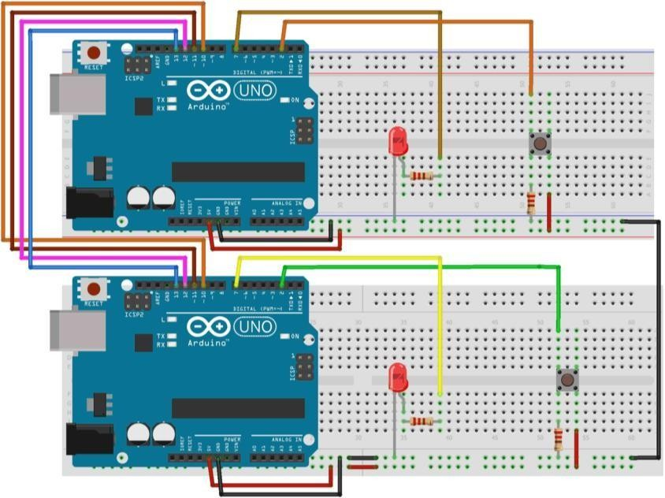
Fig. 1 Two Arduino board’s pin connections for SPI communications

Experimental Output Results:
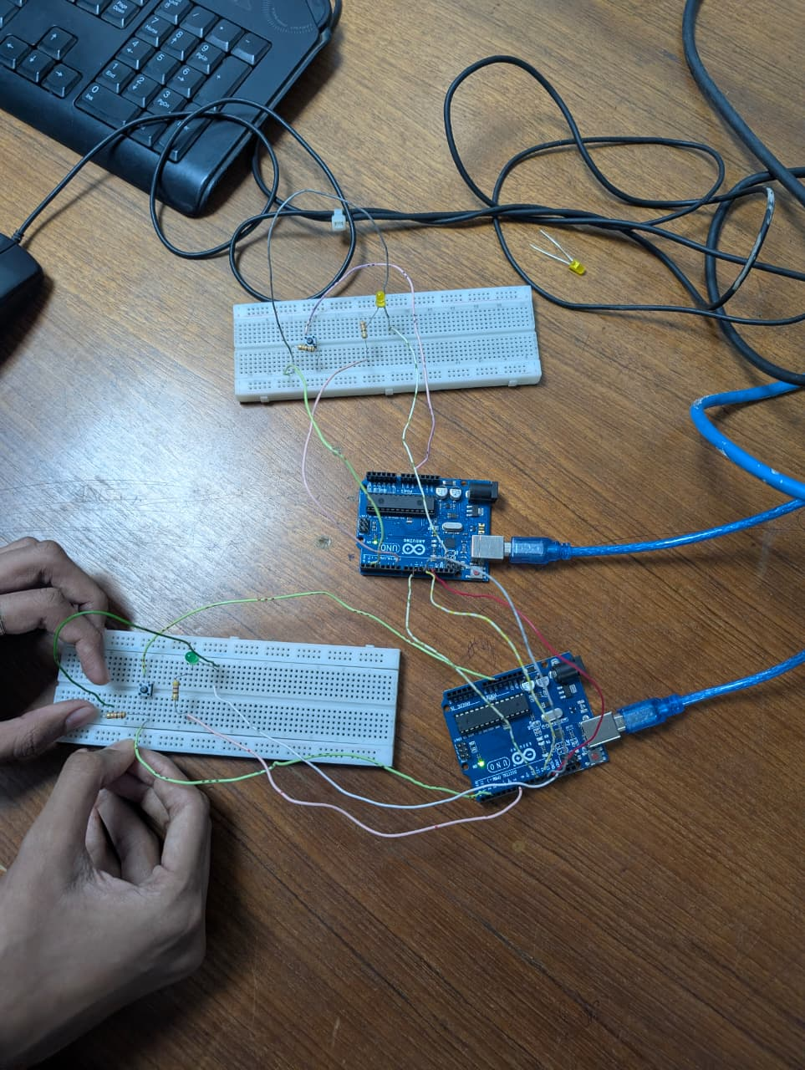
Fig:2.0 Two uno board connected without any button press.

Description: In this experiment, two Arduino boards are connected using SPI communication in a Master–Slave setup. Since the button is not pressed, no signal is sent from the master to the slave, so nothing happens in the circuit. As a result, both LEDs remain OFF, showing that the system is in an idle state without any input.

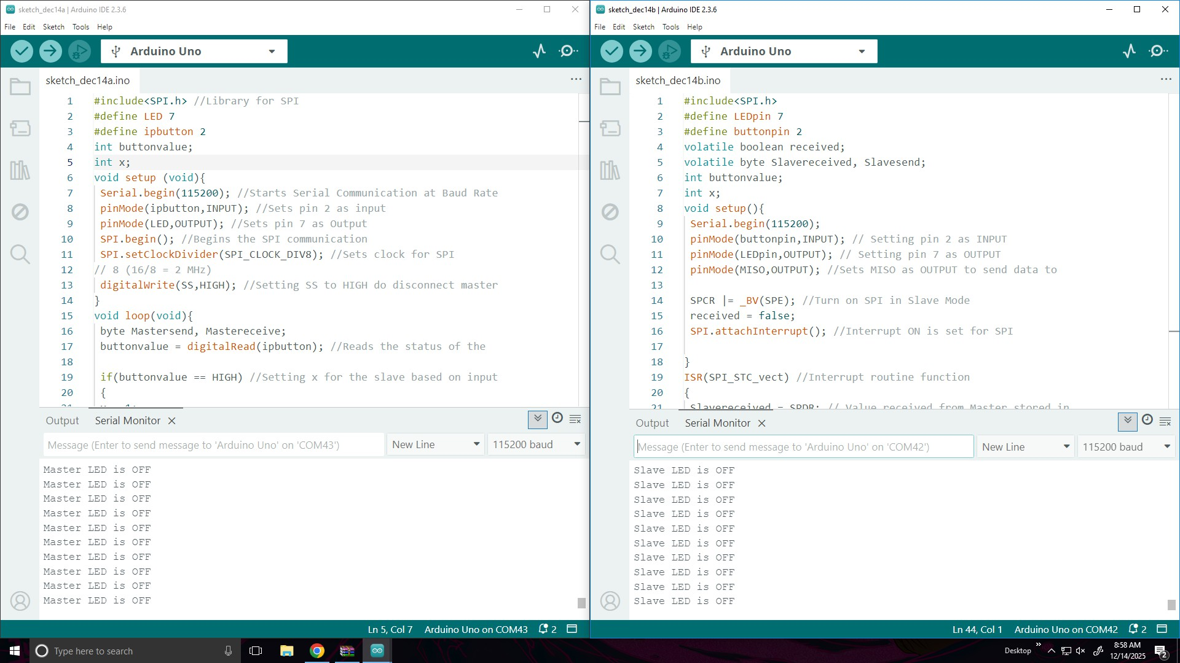
Fig. 2.1 Without Push any Button No data are transmitted.

Description: Here are code screenshot .We did not pressed any button so master LED and slave LED both is OFF.The screenshot takes from Lab computer.

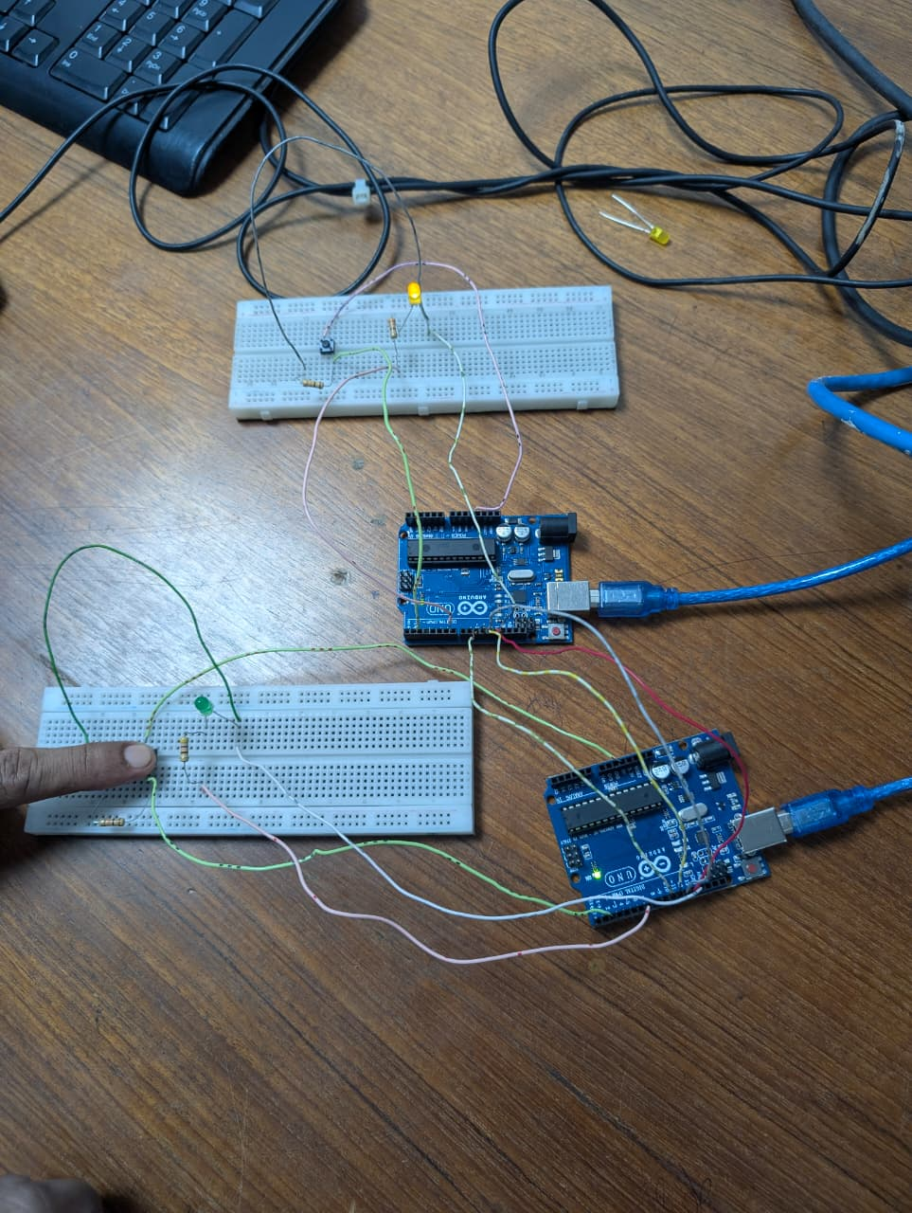
Figure 3.0 :Pressed the button Master Arduino boards so signal pass to the slave and Yellow light on .

Description : In this experiment, the master Arduino (green LED) controls the slave Arduino (yellow LED) using SPI communication. When the master switch is pressed, a signal is sent to the slave board. As shown in the picture, the slave’s yellow LED turns ON, confirming that data is successfully transmitted from master to slave.

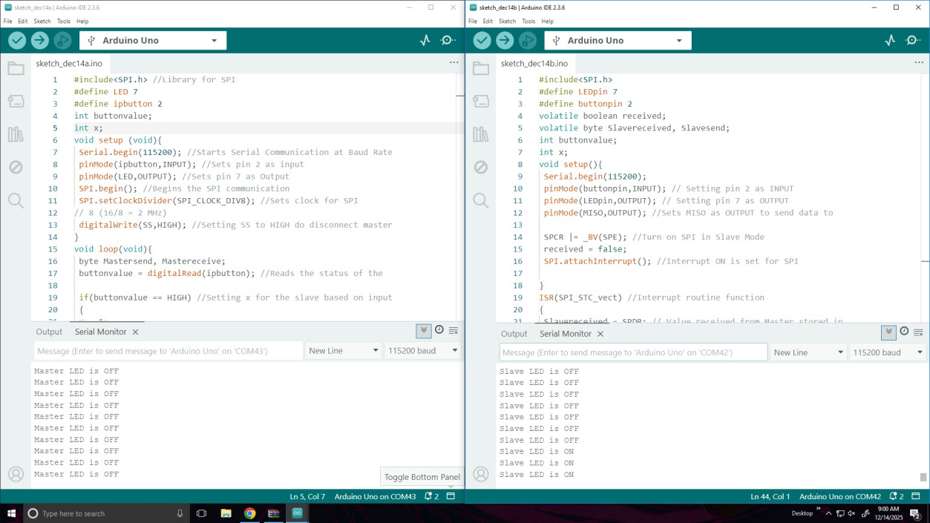

Fig. 3.1 Push Master board Button transfer data to left Arduino (slave )

Description : As we pressed the button in the master board the signal passed to the next board(slave).So in the screenshot show that the slave led is on .
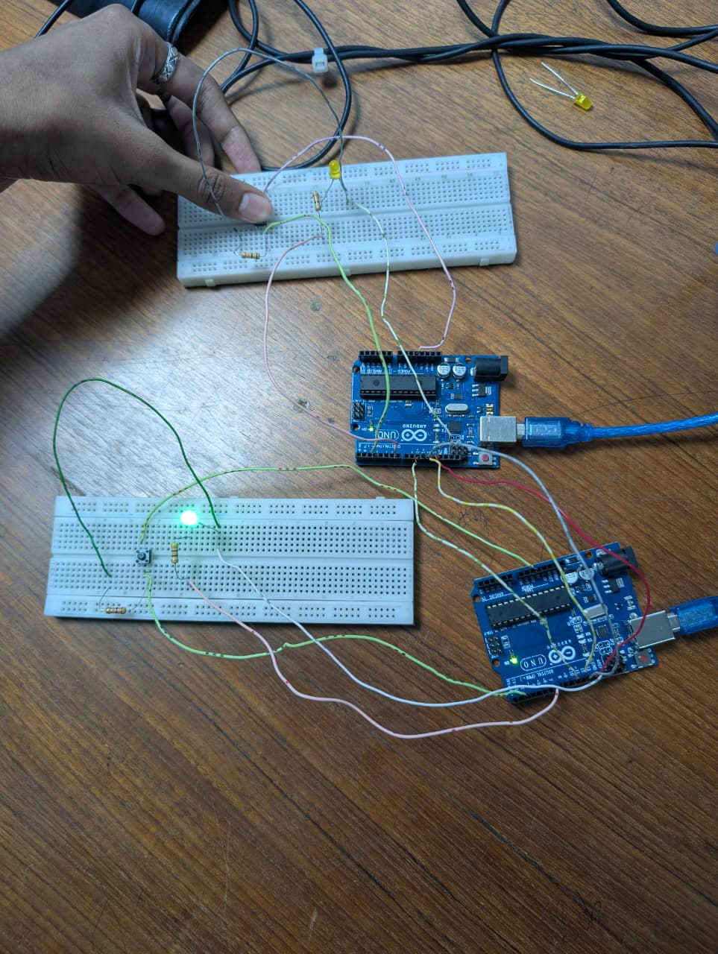

Fig. 4 Push Slave board button So green LED of the master board On.
Description: When the slave board button is pressed, a signal is sent back to the master through SPI communication. As a result, the master board’s green LED turns ON, indicating successful data transfer from the slave to the master.

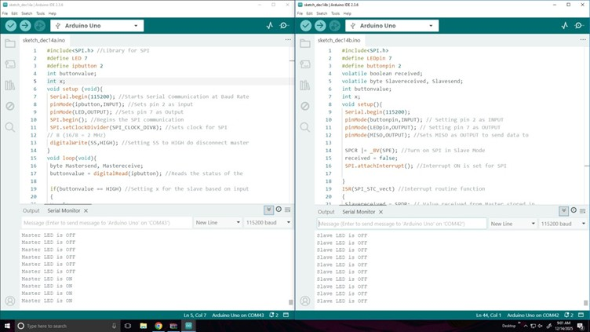

Fig. 4.1 Push Slave board button So output show that Master LED is ON.
Description: This figure shows the laptop screenshot (Serial Monitor output) when the slave board button is pressed. The output confirms that a signal is sent through SPI communication, and as a result, the master board’s green LED turns ON successfully.

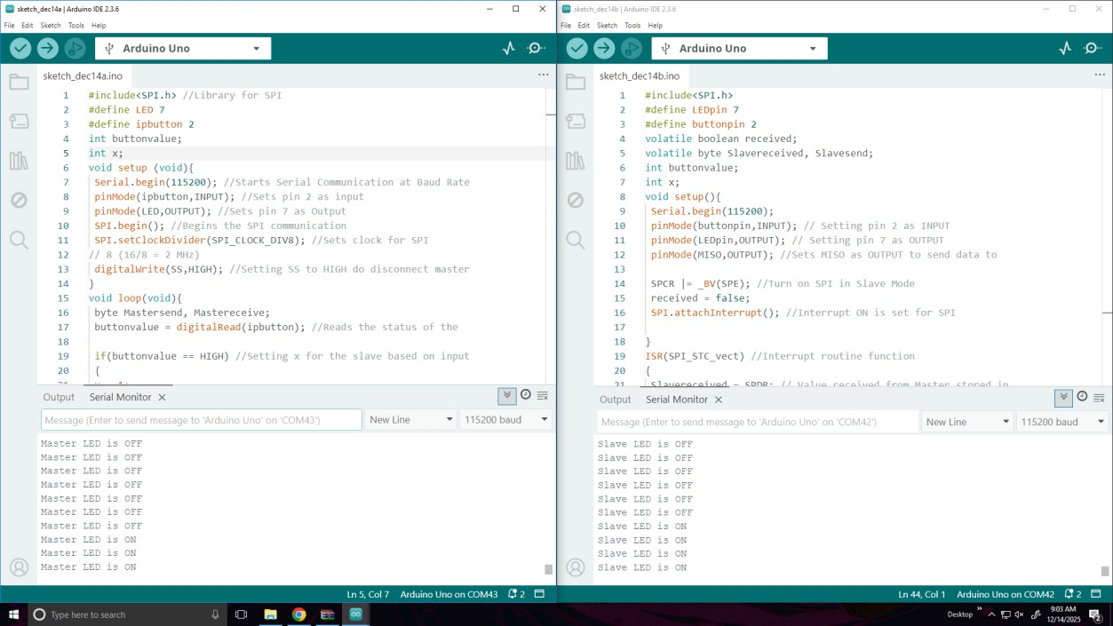
Fig. 5 Push Both Button and transmitted data Both side.

Description: Description: When both the master and slave buttons are pressed, signals are exchanged in both directions through SPI communication. As a result, both LEDs (green on master and yellow on slave) turn ON, which is also confirmed by the laptop (Serial Monitor) output, showing successful two-way communication.

Explanation: In this experiment, there were two separate experimental outcomes. At first was the result that was obtained when pressing the data transfer button at the Controller. When pressing the button at the controller, after few seconds the light on the peripheral lit up. This indicates that the data of lighting the LED of peripheral passed from controller to peripheral using the SPI communication interface. In the serial monitor of Controller, it is also found the monitor showed ‘Slave LED is ON’. When the button on the Controller was not pressed any longer, the LED connected with the Peripheral side turned OFF. As a result, this meant that the data to turn off the LED was passed through the SPI communication interface without any problem and the serial monitor shower ‘Slave LED is OFF’. Afterward the result that was obtained when pressing the data transfer button at the Peripheral. When pressing the button at the controller, after few seconds the light on the Controller lit up. This indicates that the data of turning the LED ON at the Controller passed from Peripheral to Controller using the SPI communication interface. 11 In the serial monitor of Peripheral, it is also found the monitor showed ‘Master LED is ON’. When the button on the Peripheral was not pressed any longer, the LED connected with the Controller side turned OFF. As a result, this meant that the data to turn off the LED was passed through the SPI communication interface without any problem and the serial monitor shower ‘Master LED is OFF’

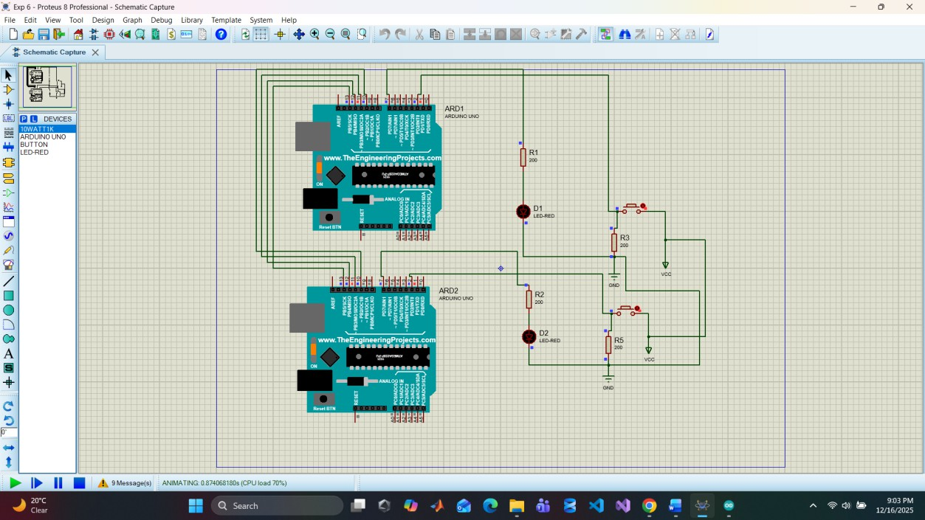

Simulations:
Fig. 6 Without Push any Button No data are transmitted.

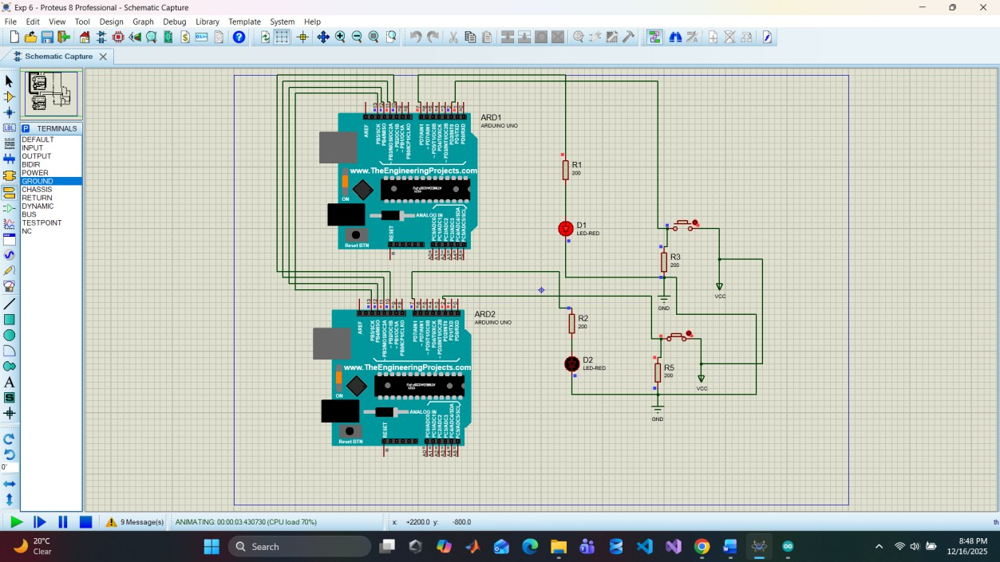
Fig. 3 Push Right Button transfer data to left Arduino

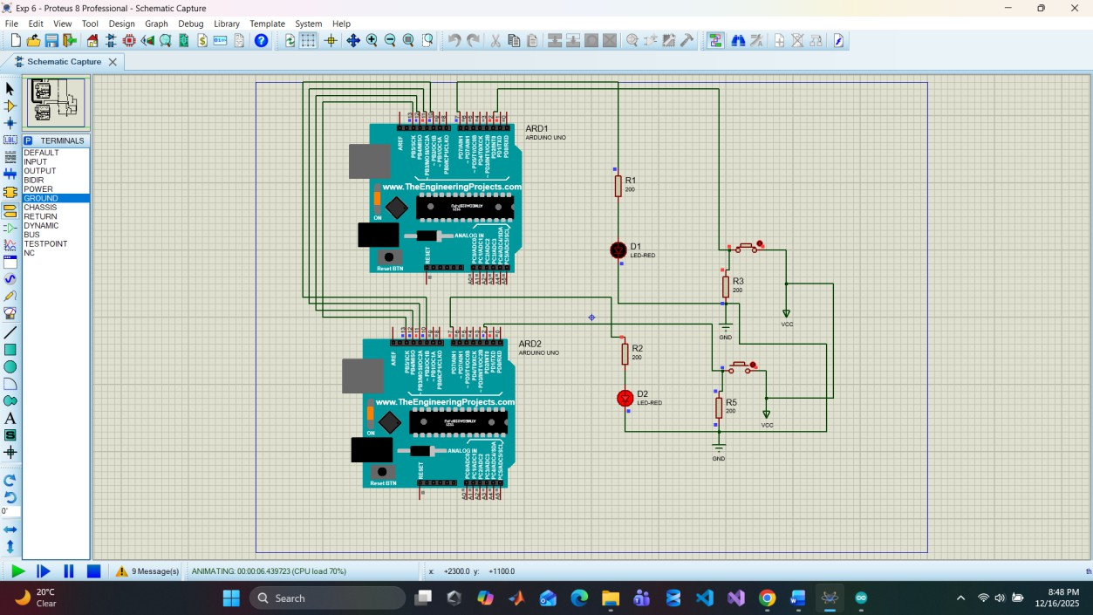
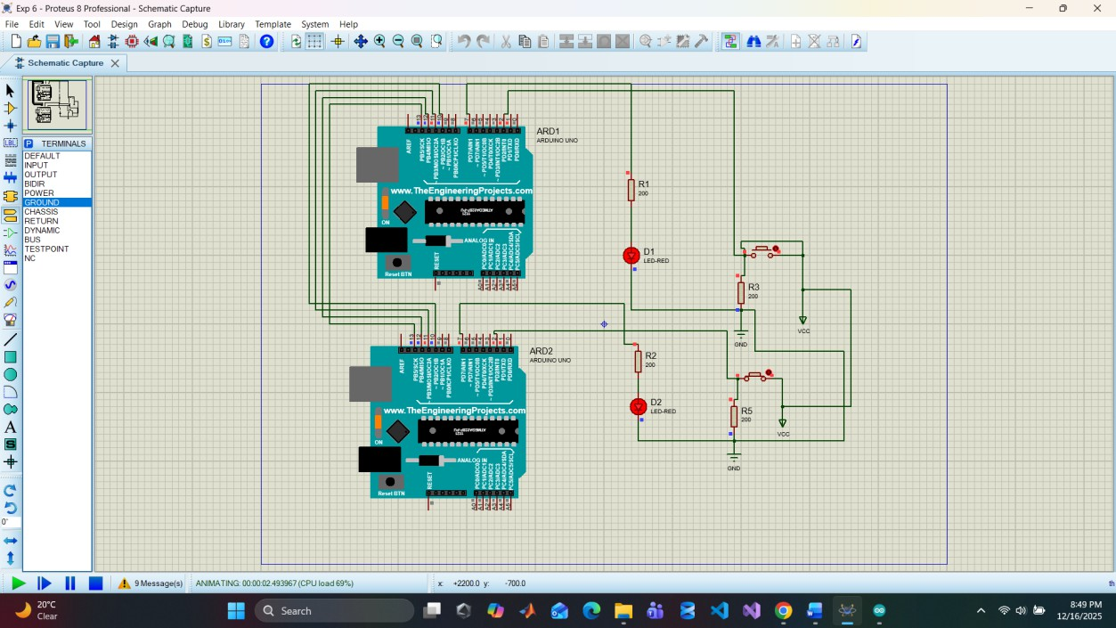
Fig. 4 Push left Button transfer data to Right Arduino

Fig. 5 Push Both Button and transmitted data Both side.

Description: In this simulation, two Arduino Uno Boards, Resistors, GREEN and RED LEDs and buttons were configured according to the instructions provided in the commented code that was used to perform the task. Buttons to pass information from one microcontroller to another were also added in the simulation and were connected accordingly based on the code comments. Both of the boards were connected using the SPI communication interface using pin 10 – 13. The program was made in the Arduino IDE and was verified. As a result, a HEX file was generated. The following HEX file was implemented in the Proteus simulation for operation related instructions of the simulation. Afterwards, the simulation was performed and the results that were obtained were noted and compared with the hardware result

Code:

Part 01:

#include<SPI.h> #define LED 7
#define ipbutton 2 int buttonvalue; int x;
void setup (void){ Serial.begin(115200);

pinMode(ipbutton,INPUT); pinMode(LED,OUTPUT); SPI.begin();
SPI.setClockDivider(SPI_CLOCK_DIV8);

digitalWrite(SS,HIGH);
}
void loop(void){
byte Mastersend, Mastereceive; buttonvalue = digitalRead(ipbutton); if(buttonvalue == HIGH)
{
x = 1;
}
else
{
x = 0;
}
digitalWrite(SS, LOW); Mastersend = x;
Mastereceive = SPI.transfer(Mastersend); if(Mastereceive == 1)
{
digitalWrite(LED,HIGH); Serial.println("Master LED is ON");
}
else
{
digitalWrite(LED,LOW); Serial.println("Master LED is OFF");
}
delay(1000);
}

Part 02

#include<SPI.h> #define LEDpin 7
#define buttonpin 2 volatile boolean received;
volatile byte Slavereceived, Slavesend; int buttonvalue;
int x;
void setup(){ Serial.begin(115200);
pinMode(buttonpin,INPUT); // Setting pin 2 as INPUT pinMode(LEDpin,OUTPUT); // Setting pin 7 as OUTPUT pinMode(MISO,OUTPUT); //Sets MISO as OUTPUT to send data to

SPCR |= _BV(SPE); //Turn on SPI in Slave Mode received = false;
SPI.attachInterrupt(); //Interrupt ON is set for SPI

}
ISR(SPI_STC_vect) //Interrupt routine function
{
Slavereceived = SPDR; // Value received from Master stored in

received = true; //Sets received as True
}
void loop() {
if(received) //To set LED ON/OFF based on the value received from

{
if (Slavereceived == 1)
{
digitalWrite(LEDpin, HIGH); //Sets pin 7 as HIGH to turn

Serial.println("Slave LED is ON");
}
else
{
digitalWrite(LEDpin,LOW); //Sets pin 7 as LOW to turn off

Serial.println("Slave LED is OFF");
}
buttonvalue = digitalRead(buttonpin); //Reads the status of the if (buttonvalue == HIGH) //To set the value of x to send to
{
x = 1;
}

else
{ x=0;
}
Slavesend = x;
SPDR = Slavesend; //Sends the x value to the Master via SPDR delay(1000);
}
}

Explanation: The Master Arduino initializes SPI communication using the SPI.begin() function and sets the SPI clock speed using SPI.setClockDivider(). A push button is read as an input to determine whether data 1 or 0 should be sent to the Slave. The SPI.transfer() function sends this data while simultaneously receiving data from the Slave.Based on the received data, the Master controls its LED and prints the LED status on the serial monitor. The Slave Select (SS) pin is pulled LOW before communication and HIGH after communication to properly enable SPI data transfer.
The Slave Arduino configures SPI in slave mode by enabling the SPI module using the SPCR register. An interrupt service routine (ISR(SPI_STC_vect)) is used to capture incoming data from the Master whenever a transfer occurs.
The received value determines whether the Slave LED turns ON or OFF. The Slave also reads its own push button state and sends a corresponding value back to the Master through the SPI Data Register (SPDR). This allows full-duplex communication between the two Arduino boards.

Discussion:
This experiment successfully demonstrated reliable two-way communication between two Arduino boards using the SPI protocol. The results showed that SPI provides fast and efficient data transfer with minimal latency compared to other serial communication protocols.
The use of interruptions on the Slave side improved system efficiency by eliminating continuous polling. Both hardware and simulation results were consistent, validating the correctness of the circuit design and program logic. This type of communication is widely used in real-life embedded systems such as sensor networks, SD card interfacing, and display modules, making SPI a crucial protocol in microcontroller-based applications.

Reference(s):

- https://www.arduino.cc/.
- ATMega328 manual
- https://www.avrfreaks.net/forum/tut-c-newbies-guide-avr-timers
- http://maxembedded.com/2011/06/avr-timers-timer0/

